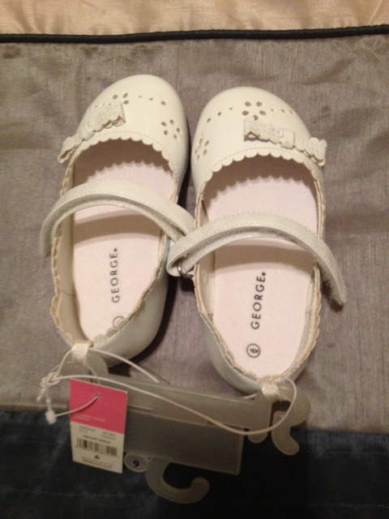 Brand new white size 6 toddler girls shoes. $3.00

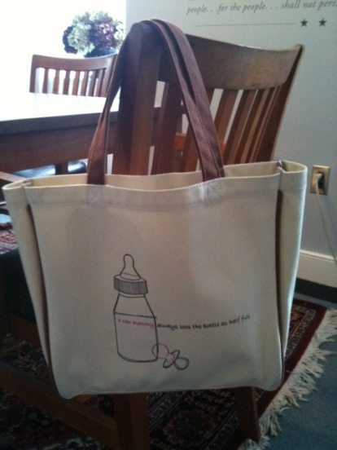

“A new mommy always sees the bottle as half full” tote bag. $5.00

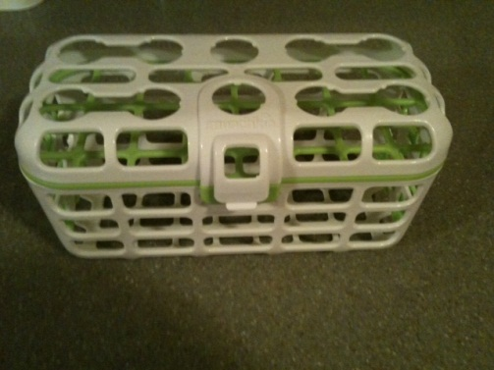

Dishwasher basket. 2 available. $3.00 for one, $5.00 for both.

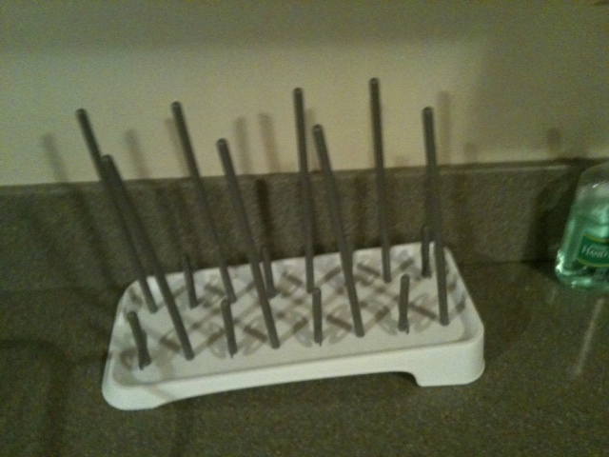

Bottle drying rack. $1.00

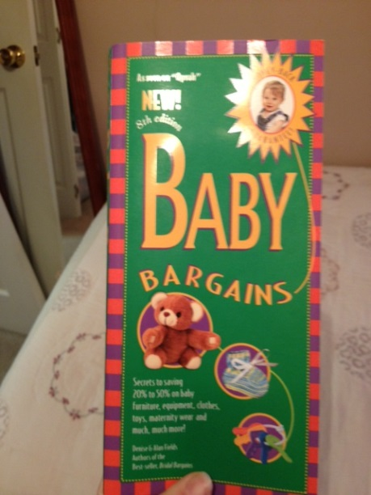 $3.00

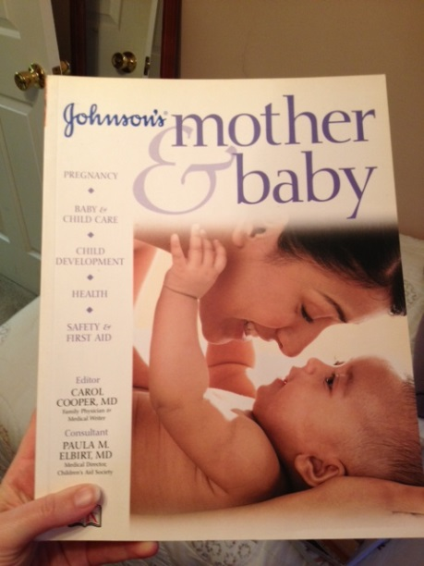 $2.00

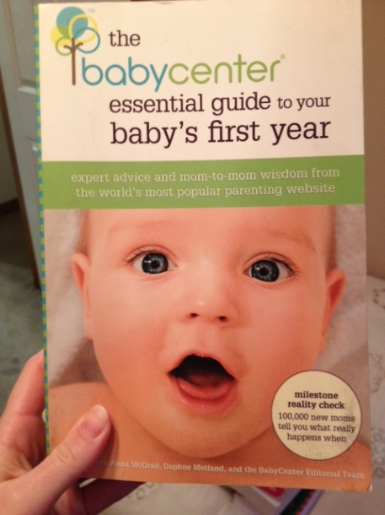 $3.00